Assay quality control
Samples were distributed across assay plates using a design that balanced maternal vaccine group and sampling time point. Each plate included blank wells, a reference preparation and in-house positive controls. Assay runs were accepted only when control measurements and bead counts met prespecified criteria. Measurements outside the validated dynamic range were repeated at an alternative dilution where sufficient sample was available.
Cross-platform harmonisation
Antibody data were drawn from two measurement platforms — a multiplexed bead-array (antigen-specific IgG and IgG subclasses, Fcγ-receptor binding, antibody-dependent complement deposition, cellular phagocytosis and neutrophil phagocytosis) and whole-cell functional assays (whole-cell IgG, the serum bactericidal assay and the pertussis-toxin neutralisation assay). All values were analysed on the log10 scale.
Because maternal and cord-blood specimens were assayed on different bead-array plates, and at different times, from the infant two-month specimens, the maternal/cord and infant timepoints were not initially on a common measurement scale; comparing them directly would have conflated true biological change with plate-to-plate and run-to-run differences in assay response. To make the timepoints comparable, the maternal and cord-blood bead-array values were calibrated onto the infant assay scale using cross-calibration parameters estimated for each feature × antigen × plate × specimen source from shared standard curves. All longitudinal change analyses spanning these specimen sources (maternal-at-delivery to cord blood, and cord blood to infant two months) were performed after this harmonisation, and the adequacy of the calibration was assessed by examining whether residual per-subject mean shifts were centred on zero (a single displaced distribution would indicate a remaining scalar offset, whereas an antigen- and analyte-structured distribution centred on zero is consistent with biological heterogeneity rather than batch effects). Total IgG, measured through a separate path, was not affected by the bead-array calibration; agreement between the total-IgG and IgG1 signals was used as an internal check that observed effects were biological rather than scaling artefacts.
Antibody representations: untransformed and IgG-standardised
Every feature-level analysis was performed in two representations. The untransformed (harmonised) representation reflects the total antibody signal and therefore captures antibody quantity. In the IgG-standardised representation, each non-total-IgG feature was regressed on its matched antigen-specific total IgG (both on the log10 scale) by ordinary least squares within the analysis frame, and the feature was replaced by the residual from that regression; total-IgG features were carried through unchanged. The residual expresses the feature relative to the amount of antigen-specific IgG present, so the standardised representation captures antibody composition or quality independent of bulk IgG magnitude. The three whole-bacterium functional assays, which have no single antigen of their own, were standardised against a single representative antigen's total IgG — pertactin for the serum bactericidal assay and whole-cell IgG, and pertussis toxin for the pertussis-toxin neutralisation assay; because a whole-cell function is supported by antibodies to several antigens, the resulting standardised values were interpreted with this limitation in mind. Robustness of the residuals to influential observations and to departures from linearity was confirmed with Huber-weighted regression and a monotone spline fit as sensitivity analyses. An effect that persisted after standardisation was interpreted as a qualitative (composition) effect rather than a consequence of bulk antibody concentration.
Outcomes and exposures
The principal functional outcomes were the three whole-cell readouts — the serum bactericidal assay, the pertussis-toxin neutralisation assay and whole-cell IgG — supported by antigen-specific IgG and IgG1 to the vaccine antigens (pertussis toxin, filamentous haemagglutinin, pertactin, fimbriae, diphtheria toxoid and tetanus toxoid). Infant outcomes were examined at the pre-primary two-month baseline, before the infant primary series. Maternal antibody was measured at two draws — early pregnancy (pre-vaccination) and delivery.
The two randomised exposures were the maternal vaccine arm (pertussis-containing Tdap-IPV versus a tetanus-toxoid comparator, TT) and the infant priming schedule (acellular, aP, versus whole-cell, wP), giving a 2 × 2 factorial structure. Throughout, the maternal arm was modelled with TT as the reference, so that a Tdap-IPV coefficient on the log10 scale corresponds, after exponentiation, to a multiplicative Tdap-IPV-versus-TT effect. Because every analysis in this part concerns the pre-primary baseline — which precedes the infant priming schedule — the two infant priming arms were pooled for the maternal-arm comparisons unless stated otherwise. The continuous antibody predictors were maternal antigen-specific concentrations (at delivery and, for the chain analysis, early pregnancy) and the matched infant two-month antibody, as defined under each analysis below.
Clinical and obstetric variables
Clinical variables considered as potential modifiers or adjustment variables included maternal age, parity, body-mass index at enrolment, maternal haemoglobin, mode of delivery, gestational age at maternal vaccination, interval from maternal vaccination to delivery, gestational age at birth, birthweight, infant sex and interval from birth to infant month-2 sampling.
Covariate selection
Adjustment variables were specified a priori rather than chosen by data-driven univariate screening. The confirmatory analyses were defined in advance (the whole-cell outcomes and the pertussis axis at the two-month baseline, in both the untransformed and standardised representations), and the structural model terms — maternal arm and the matched antibody predictors — were entered by design. For the predictive models, a small, biologically motivated confounder was pre-specified per outcome (maternal arm and maternal age), and the sensitivity of the conclusions to a wider clinical confounder block (maternal age, maternal haemoglobin, maternal body-mass index, birthweight and gestational age at birth) was then evaluated as a secondary comparison rather than used for selection.
Analyses
Analyses comprised five components, sharing one harmonised modelling frame and the untransformed/standardised duality described above. All analyses were performed in R.
Cross-sectional maternal-arm contrast at the pre-primary baseline. At the infant two-month baseline, every systems-serology feature was compared between the two maternal vaccine groups, pooling the infant priming arms. For each antigen × analyte feature the maternal-arm effect was summarised on the log10 scale as the difference in medians (median[TT] − median[Tdap-IPV]; a negative value denoting a higher level after Tdap-IPV) and as the corresponding fold-difference (anti-log10 of the Tdap-IPV − TT median difference, Tdap-IPV relative to TT). Group differences were tested with two-sided Wilcoxon rank-sum (Mann–Whitney) tests and corrected for multiplicity by the Bonferroni method across all tested antigen × analyte combinations, with adjusted p<0.05 considered significant. The three whole-bacterium functional assays were displayed and analysed under a representative antigen (pertussis-toxin neutralisation under pertussis toxin; serum bactericidal activity and whole-cell IgG under pertactin). The contrast was run in both representations, so that an effect surviving IgG-standardisation indicated a difference in antibody composition independent of antigen-specific abundance.
Within-individual antibody change across the maternal–infant chain. Three paired within-subject analyses characterised antibody change across consecutive timepoints: from early-pregnancy pre-vaccination to maternal delivery (the vaccine-boost step), from maternal delivery to cord blood (transplacental transfer), and from cord blood to infant two months (neonatal decay before primary immunisation). For each feature the per-subject change was the difference in log10 values between the later and earlier visit, so that positive values denote an increase (for transfer, cord exceeding maternal; for decay, a level above the cord value). Per-feature change was summarised by the median change, the proportion of subjects increasing, and Wilcoxon signed-rank and sign tests, and each feature was classified as predominantly increasing, predominantly decreasing or mixed. Results were aggregated by analyte, by antigen and by maternal arm; an arm-specific pattern was taken to indicate a vaccine-driven effect and an arm-shared pattern a shared developmental effect. Coverage and the structure of missing data were tabulated explicitly before interpretation (see Missing data).
Predictors of maternal responder status. To characterise variation in the maternal antibody available for transfer, mothers were classified as Low or High responders from their pertussis-specific binding IgG across the two maternal draws, and the predictors of this class were examined with the maternal vaccine arm as the only stratifier (infant priming is not relevant to a maternal property). The vaccine arm alone was first quantified as the baseline classifier (area under the receiver-operating-characteristic curve, AUC). Each of ten clinical and obstetric covariates was then screened against the responder score (linear regression) and against the Low/High class (logistic regression), overall and within each arm, and entered into a maternal-arm-adjusted logistic model; only covariates remaining associated after arm adjustment were taken to add information beyond the vaccine. Finally, a maternal-serology signature was assessed: all maternal antigen × analyte features, excluding the four features that defined the responder score to avoid circularity, were Blom-standardised and entered into an arm-adjusted elastic-net logistic model (the arm forced in unpenalised), with performance summarised by 10-fold cross-validated AUC and compared against the arm-only classifier; a pre-vaccination (early-pregnancy) feature set was modelled separately to test whether responder status was detectable before vaccination. These analyses are descriptive and predictive rather than causal.
Maternal antibody at delivery as a predictor of infant function. For each whole-cell outcome at the infant two-month baseline, maternal antigen-specific total IgG at delivery was used as the predictor. An initial multivariable ordinary-least-squares model contained maternal pertussis-toxin-, FHA- and pertactin-specific total IgG, so that the independent (conditional) contribution of each could be read; coefficients were reported in standardised form and overall fit as R². Each model was then expanded to add maternal fimbriae-, diphtheria-toxoid- and tetanus-toxoid-specific total IgG, and the incremental R² recorded. To test whether the maternal antibody–infant function relationship differed by maternal vaccine background, the expanded model was fitted separately within each maternal arm (reporting the variance explained in each), and a formal maternal-group × antibody interaction was fitted using the matched antigen-specific IgG1 as the predictor (pertussis-toxin IgG1 for neutralisation, pertactin IgG1 for the two surface outcomes), standardised and adjusted for maternal age, with the group × antibody coefficient providing the slope-difference test; the same interaction was also fitted with the concurrent two-month infant IgG1 as a within-infant secondary test. Because both the antibody predictor and the functional readout are measured with error, the antibody–function relationship was additionally estimated by Deming (errors-in-variables) regression within each maternal arm, assuming an error-variance ratio λ = 1 (orthogonal regression); per-arm slopes and their difference were obtained by a stratified subject-level bootstrap (2000 resamples). Because the comparator-arm antibody range is narrow, the Deming slope-difference was reported as a range-limited sensitivity analysis, with the standardised interaction taken as the primary slope test.
Concurrent infant models and the maternal-versus-concurrent contrast. For each whole-cell outcome at the two-month baseline a predictive model was also built hierarchically from the infant's own two-month measurements: maternal arm, then the pre-specified clinical confounder, then matched antigen-specific total IgG, then matched IgG1, then an effector block (Fcγ-receptor 2a binding and antibody-dependent complement deposition for all six antigens), with each block's incremental adjusted R² evaluated. Model performance was summarised by in-sample fit penalised for parameters (adjusted R², AIC) and by honest out-of-sample error from 10-fold cross-validation (cross-validated RMSE and R²); models were compared on cross-validated error and parsimony rather than on raw R², and the sensitivity to the wider clinical confounder block was evaluated here. Because part of what a whole-cell assay measures is re-measured by the antigen-specific assay on the same blood draw, a concurrent predictor measured at two months can share measurement variance with the outcome and inflate apparent prediction. To separate honest forward prediction from same-occasion co-measurement, the matched antibody terms were entered from two timepoints — a concurrent model using the two-month (same-draw) measurement, and a maternal model using the temporally prior maternal-at-delivery measurement, which cannot share a measurement occasion with the outcome — contrasted directly and then combined. A large excess of the concurrent over the maternal R², with a much smaller concurrent residual standard deviation and concurrent terms that retained significance while the prior terms attenuated, was taken as the signature of shared-sample co-measurement. The maternal-at-delivery model was therefore reported as the primary forward predictor, and the concurrent model as a descriptive upper bound, with the magnitude of the inflation reported explicitly. Cross-validation controls optimism but not this same-occasion confound, since a concurrent predictor co-measures the outcome within every fold; the maternal-versus-concurrent contrast, not cross-validation, is what addresses it.
Missing data and model diagnostics
Sample availability differed across features, and the sources of missingness were distinguished because they carry different implications for bias: features not assayed at a given visit (a structural panel gap, not correctable from the data); panels run on different subject sub-cohorts at the two visits (a batch/rollout structure); subjects present at one visit but not the other (dropout, which contributes to a cross-sectional count but not to a paired comparison); and feature-level quality-control failures within otherwise-assayed subjects. For each paired comparison, per-feature coverage (the number of subjects with a valid value at each visit and at both) was tabulated and displayed as coverage heatmaps and waterfall plots, and the subject-level coverage pattern was inspected for the discrete plateaus that signal assay-batch structure. Analyses used the subjects with complete data for the variables in each model (complete-case analysis); models within a family were fitted on a common set of rows so that information criteria, cross-validation and nested tests were comparable, and a minimum number of complete observations was required before a model was estimated. No imputation was performed; the limitation that subjects contributing to one analyte's analysis may not be the same population as another's was noted where features were pooled.
Model adequacy was assessed by inspection of residual-versus-fitted and normal quantile–quantile plots for the selected models, with formal tests of residual normality (Shapiro–Wilk) and homoscedasticity (Breusch–Pagan) reported alongside the fit statistics. For the multivariable predictive models, collinearity among predictors was assessed by variance-inflation factors and by the correlation matrix of the coefficient estimates. The least-powered estimates — the interaction and per-arm slope contrasts and the Deming slope-difference — were interpreted from their (bootstrap) confidence intervals rather than their point estimates.
A. At two months, maternal Tdap-IPV raised infant pertussis-specific antibody and function, driven by abundance rather than altered quality
Unstandardised (absolute) systems-serology profile (figure 1; supplementary table S1)
We first compared the pre-primary systems-serology profiles of infants born to mothers who received Tdap-IPV or tetanus toxoid during pregnancy (figure 1; supplementary table S1). At two months of age, maternal Tdap-IPV was associated with substantially higher antigen-specific total IgG for all three pertussis antigens contained in the maternal vaccine — pertussis toxin (16.4-fold), FHA (21.9-fold) and pertactin (59.1-fold; all adjusted p<0.0001) — together with higher values across most IgG subclasses, both FcγRIIa- and FcγRIIIb-binding assays, and complement deposition (ADCD). Antibody-dependent phagocytosis was also higher following Tdap-IPV for several antigen targets, although the difference did not reach significance for pertussis toxin-specific neutrophil phagocytosis (ADNP) or pertactin-specific monocyte phagocytosis (ADCP) after correction (figure 1). Consistent with these binding differences, the two whole-bacterium functional measures were markedly higher following maternal Tdap-IPV: pertussis toxin-neutralising activity (displayed under pertussis toxin) was 4.0-fold higher and serum bactericidal activity (displayed under pertactin, the antigen that dominates this response) was 22.8-fold higher than in infants born to tetanus toxoid-vaccinated mothers (both adjusted p<0.0001). FIM2/3-specific total IgG and IgG subclasses did not differ between the maternal groups after correction, in keeping with FIM antigens being absent from both maternal vaccines; only small differences in FIM2/3 Fcγ-receptor binding reached significance (FcγRIIa 1.5-fold, FcγRIIIb 1.1-fold). Diphtheria-toxoid responses were higher following Tdap-IPV (total IgG 5.2-fold; adjusted p<0.0001), whereas tetanus-toxoid-specific responses did not differ significantly between groups for any readout, consistent with tetanus toxoid being present in both maternal vaccines.
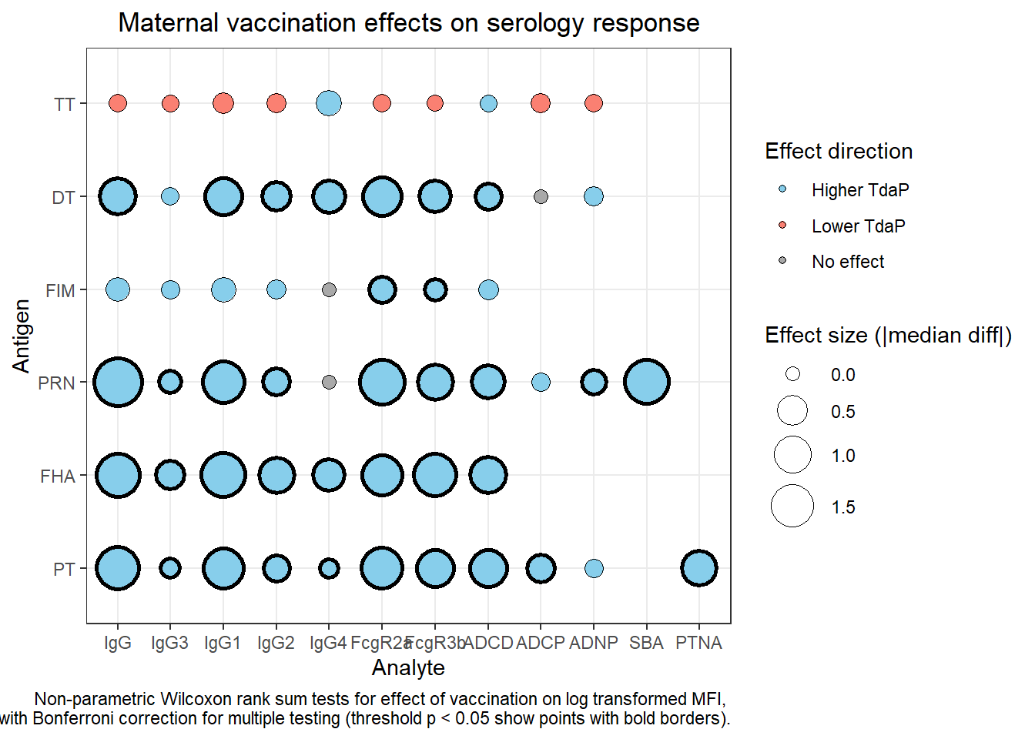
Figure 1. Maternal-arm contrast in the infant two-month systems-serology profile (untransformed). Each bubble is one antigen × analyte feature; bubble size is the absolute median log₁₀ difference between maternal groups, fill shows the direction (blue, higher after Tdap-IPV; salmon, higher after tetanus toxoid; grey, no significant difference), and a bold border marks adjusted p<0.05 (Wilcoxon rank-sum, Bonferroni). Whole-bacterium assays appear at the right (SBA under pertactin, PTNA under pertussis toxin). Full statistics are in supplementary table S1.
Standardised systems-serology profile, relative to antigen-specific total IgG (figure 2; supplementary table S2)
To determine whether the greater Fc-mediated activity reflected antibody abundance or a distinct antibody phenotype, each subclass and functional measurement was standardised to the corresponding antigen-specific total IgG signal (figure 2). After standardisation, the differences in FcγRIIa binding, FcγRIIIb binding, ADCD, ADCP and ADNP for the pertussis antigens were largely attenuated and, in most cases, no longer significant, indicating that the higher absolute Fc-mediated activity following maternal Tdap-IPV was principally explained by the greater quantity of antigen-specific antibody transferred rather than by a uniform increase in activity per unit of total IgG. Two residual Fc-effector differences nonetheless persisted, both higher following Tdap-IPV: pertussis toxin-specific complement deposition (1.7-fold relative to total pertussis toxin IgG) and FHA-specific FcγRIIa binding (1.4-fold; both adjusted p<0.0001). The two whole-bacterium functional readouts behaved differently once expressed relative to antigen-specific IgG: pertussis toxin-neutralising activity no longer differed between the maternal groups (per unit pertussis toxin IgG; adjusted p=0.68), indicating that its large absolute difference was abundance-driven, whereas serum bactericidal activity per unit pertactin IgG was modestly lower following maternal Tdap-IPV (0.57-fold, i.e. relatively higher in the tetanus-toxoid group; adjusted p=0.017).
Smaller antigen-specific differences in subclass composition remained. Relative to total pertussis toxin IgG, pertussis toxin IgG3 (0.5-fold), IgG2 (0.8-fold) and IgG4 (0.7-fold) were lower following maternal Tdap-IPV (all adjusted p<0.0001), whereas pertussis toxin IgG1 did not differ between groups (adjusted p=1.00). FHA showed the clearest relative shift towards IgG1 (1.6-fold higher with Tdap-IPV; adjusted p<0.0001) and away from IgG3 (0.8-fold; adjusted p=0.016), and pertactin IgG3 was also relatively lower following maternal Tdap-IPV (0.5-fold; adjusted p<0.0001), with a small relative increase in pertactin IgG4 (1.1-fold; adjusted p=0.0004). Minor relative differences were also seen for diphtheria toxoid (lower IgG3 with Tdap-IPV; 0.5-fold) and FIM2/3 (slightly higher IgG1 with Tdap-IPV; 1.4-fold). These patterns indicate differences in subclass composition but do not, in themselves, establish differences in activity per antibody molecule.
Taken together, after accounting for antigen-specific antibody abundance the pertussis-specific responses elicited by maternal Tdap-IPV were largely similar in quality to those in the tetanus-toxoid group, with three exceptions: modestly enhanced pertussis toxin-directed complement-fixing function (ADCD, 1.7-fold) and FHA-directed FcγRIIa binding (1.4-fold) per unit IgG, and modestly lower serum bactericidal activity per unit pertactin IgG (0.57-fold). The bactericidal-activity result should be interpreted cautiously, since serum bactericidal activity is a whole-cell function supported by antibodies to several antigens and is here standardised to a single antigen's IgG; in the tetanus-toxoid group, where pertactin-specific IgG is minimal, residual bactericidal activity is more likely to reflect non-pertactin antibody and therefore appears high relative to pertactin IgG. Overall, maternal Tdap-IPV principally expanded the amount of pertussis-specific antibody transferred to infants, with limited and mixed evidence of differences in antibody quality.
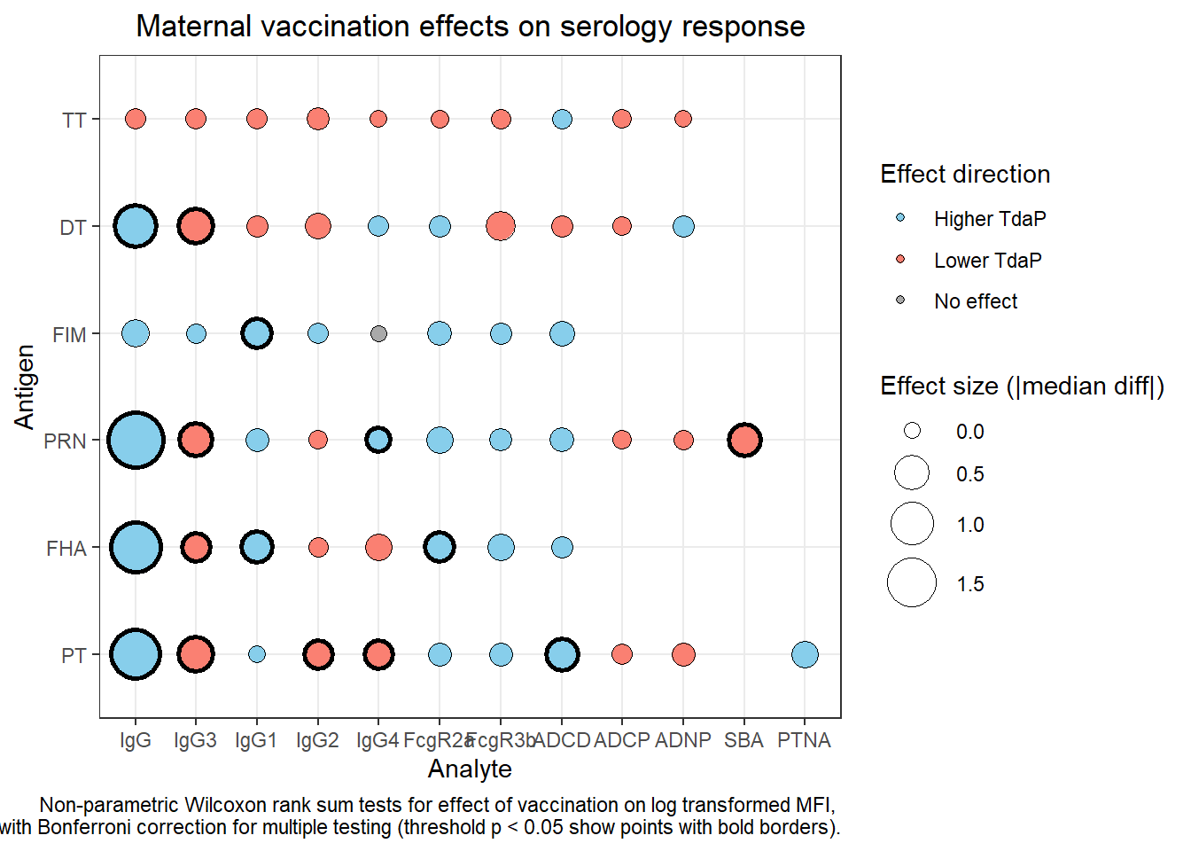
Figure 2. The same contrast after IgG-standardisation (each feature expressed relative to its matched antigen-specific total IgG). Most Fc-effector and phagocytosis differences for the pertussis antigens attenuate to non-significance; residual signals remain (pertussis toxin complement deposition and FHA FcγRIIa binding higher after Tdap-IPV; serum bactericidal activity per unit pertactin IgG lower after Tdap-IPV). Encoding as in figure 1; full statistics in supplementary table S2.
B. Maternal antibody abundance at delivery predicted infant functional activity more strongly than transfer efficiency or postnatal decay
We traced the antibody pathway from maternal sampling before vaccination (PregEarly) through delivery (MatBirth), cord blood and the pre-primary infant sample at two months (InfMon2), and asked, within the Tdap-IPV group, which step of the pathway governed infant functional activity (figure 3). Three within-subject transitions describe the pathway: maternal production of antibody during pregnancy (PregEarly→MatBirth), placental transfer to the infant (MatBirth→CordBlood), and postnatal decay of the maternally derived pool (CordBlood→InfMon2).
Maternal vaccination raised the antigen-specific antibodies the placenta transfers best. From before vaccination to delivery, total IgG to the three Tdap-IPV pertussis antigens increased (median Δlog₁₀ +0.16 for pertussis toxin, +0.14 for B pertussis filamentous haemagglutinin [FHA] and +0.14 for pertactin, with 70–75% of mothers rising), and the largest subclass rise was in IgG1 (for example FHA IgG1 +0.29). Tetanus-toxoid IgG, present in both maternal vaccines, did not increase materially (median Δlog₁₀ −0.01), and diphtheria-toxoid and FIM2/3 IgG rose only modestly (figure 3, left).
Placental transfer then established the infant pool without strongly reshaping it. Cord concentrations modestly exceeded maternal concentrations for every antigen total IgG (median Δlog₁₀ +0.04 to +0.11), consistent with efficient, FcRn-mediated transfer rather than a step that introduced large between-dyad differences (figure 3, middle). Measures of maternal-to-cord transfer quantity and subclass-selective transfer added little information beyond maternal antibody concentration at delivery: placental transfer was necessary to establish the infant antibody pool, but variation in infant outcomes was more closely associated with the amount of relevant maternal antibody available for transfer than with differences in transfer efficiency between mother–infant pairs.
Postnatal decay was the dominant change along the pathway and was non-selective. Total antigen-specific IgG declined between cord blood and two months in 95–99% of infants, with median changes of approximately −0.57 to −0.62 log₁₀ (figure 3, right). IgG1 also declined across most antigen-specific measurements (median across the antigen-specific IgG1 measurements ≈ −0.26 log₁₀; range −0.15 to −0.41). The only subclass signal that did not decline was a small residual increase in pertussis toxin IgG3 (median Δlog₁₀ +0.26), which occurred close to the lower limit of the assay range and was interpreted cautiously; after cross-plate normalisation the broader IgG3 pattern was a small positive residual (≈ +0.13) rather than a true biological rise. These findings confirm the expected postnatal decay of maternally derived total IgG and IgG1, with no selective persistence of any subclass. Consistent with this, measures of cord-to-infant antibody change added little robust predictive information beyond maternal antibody concentrations at delivery.
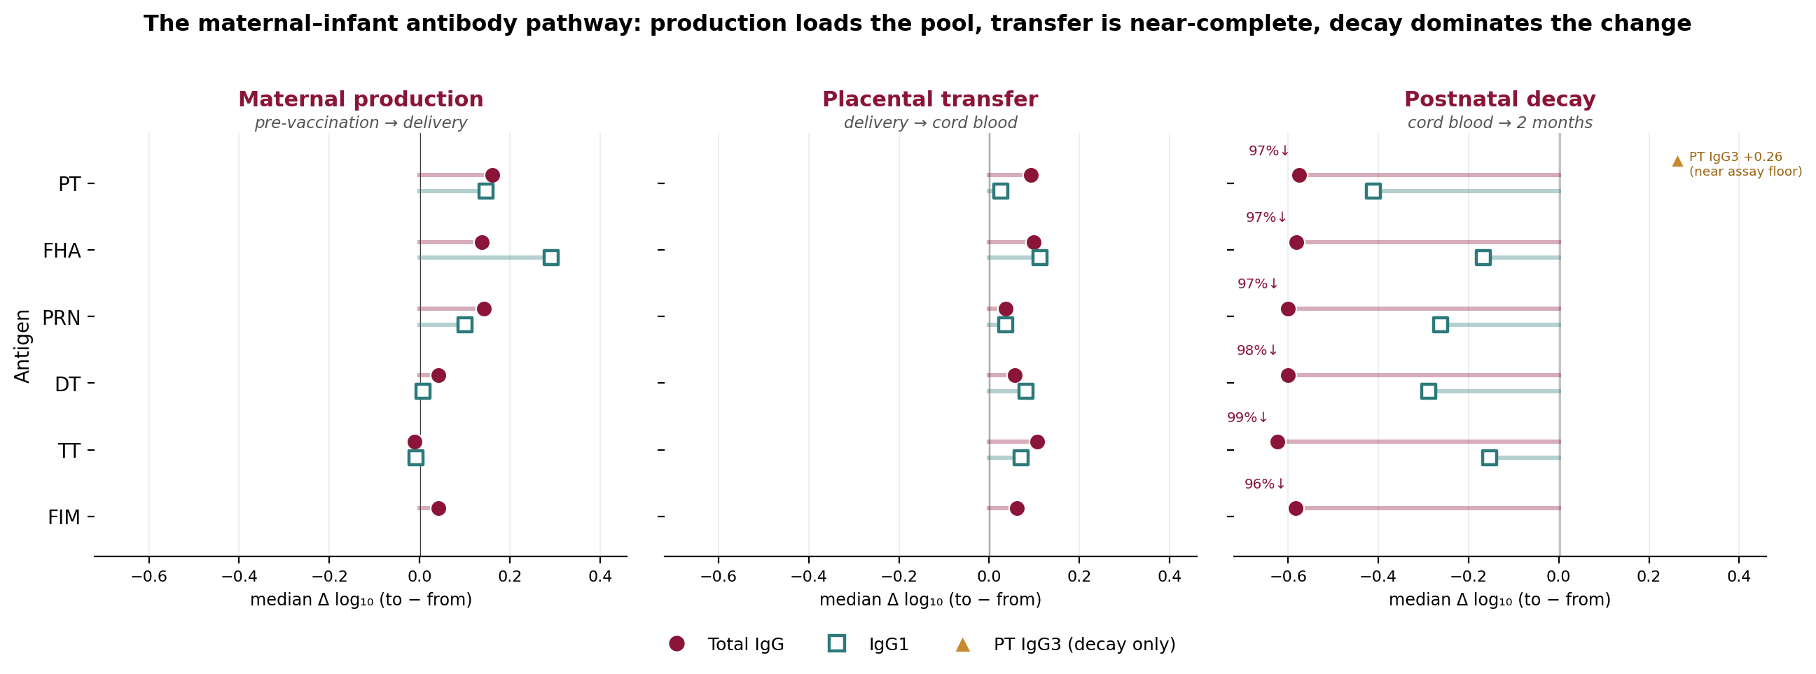
Figure 3. The maternal–infant antibody pathway across three within-subject transitions. Points are per-feature median within-subject change (Δlog₁₀ = log₁₀ value at the later visit minus the earlier visit) for total IgG (filled circles) and IgG1 (open squares) for each antigen; the orange triangle marks the pertussis toxin IgG3 residual in the decay panel. Percentages in the decay panel are the proportion of infants declining. A shared x-axis shows that production (left) raises the Tdap-IPV antigens, transfer (middle) is near-complete and small in magnitude, and decay (right) is the largest and most uniform change. Pertussis-toxin-neutralising activity and serum bactericidal activity are not subclass features and are summarised in tables 3–7.
Transition | Antigen total IgG (median Δlog₁₀) | % subjects changing as expected | IgG1 (median Δlog₁₀)
Production (PregEarly→MatBirth) | +0.04 to +0.16 (PT/FHA/PRN rise; TT flat) | 70–75% increase (PT/FHA/PRN) | up to +0.29 (FHA)
Transfer (MatBirth→CordBlood) | +0.04 to +0.11 (all antigens) | 61–79% increase (cord ≥ maternal) | +0.03 to +0.11
Decay (CordBlood→InfMon2) | −0.57 to −0.62 (all antigens) | 95–99% decrease | ≈ −0.26 (median)
Table 1. Summary of the three antibody-pathway transitions (within-subject paired change, Wilcoxon signed-rank p<0.0001 for all total-IgG rows). Production and transfer load and deliver the antigen-specific pool; postnatal decay is the largest and most uniform change. Pertussis toxin IgG3 was the only subclass to rise from cord to two months (+0.26), close to the assay floor.
Between-mother variation in transferable antibody reflected the maternal vaccine and a pre-existing breadth trait, not clinical characteristics
Because the amount of relevant maternal antibody available at delivery was the principal determinant of infant function (section B), we asked what distinguished mothers who mounted a strong (High) from a weak (Low) antibody response. Mothers were classified as Low or High responders from their pertussis-specific binding IgG across the two maternal draws. As expected, this class was largely a function of the maternal vaccine: maternal arm alone separated Low from High responders with an AUC of 0.74 (Tdap-IPV mothers predominantly High, tetanus-toxoid mothers predominantly Low), although the separation was incomplete (66 of 161 tetanus-toxoid mothers were High responders and 20 of 144 Tdap-IPV mothers were Low).
No maternal clinical or pregnancy characteristic predicted responder status beyond the vaccine. Maternal age, body-mass index, parity, haemoglobin, gestational age at vaccination or delivery, the vaccination-to-delivery interval, delivery mode and infant sex were each uninformative (within-arm AUC 0.50–0.64, no consistent signal) and none remained associated after adjustment for maternal arm (arm-adjusted logistic model: Tdap-IPV odds ratio 9.0, p<0.0001; all clinical terms non-significant). This maternal clinical null parallels the infant-level clinical null (section F) and indicates that the maternal-arm contrasts in this study are not confounded by demographic differences in maternal responsiveness.
The mother's own antibody profile, by contrast, predicted her responder status. An arm-adjusted penalised model using all maternal antigen×analyte features — excluding the four features that defined the responder score — classified Low versus High responders at a cross-validated AUC of 0.92, well above the arm-only 0.74, and pre-vaccination (early-pregnancy) serology alone reached 0.88 (figure 4, left). The signal was led by B pertussis filamentous haemagglutinin (FHA) IgG (univariate AUC 0.90; an antigen not used to define the score) and spanned the non-defining IgG subclasses of pertussis toxin and pertactin, FIM2/3, and the co-administered diphtheria and poliovirus antigens (figure 4, right). High responder status was therefore a coordinated, panel-wide breadth phenotype that was already detectable before vaccination, indicating that between-mother variation in transferable antibody was partly a pre-existing property of the maternal repertoire that the vaccine amplified, rather than a clinically identifiable trait. This complements the abundance-dominated infant profile of section A and the more coherent maternal pertactin–infant function relationship after Tdap-IPV (section D).
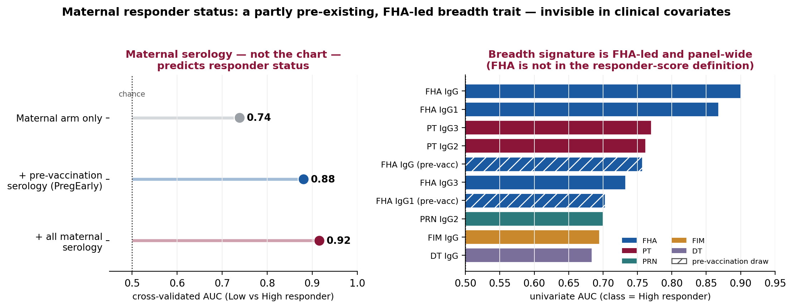
Figure 4. Determinants of maternal responder status. Left: cross-validated AUC for classifying Low vs High responders — the maternal arm gives 0.74, pre-vaccination serology alone 0.88, and all maternal serology 0.92. Right: top maternal serology features by univariate AUC, coloured by antigen (hatched = pre-vaccination draw); the signature is FHA-led and panel-wide. Clinical covariates (not shown) were uninformative.
Predictor of maternal Low/High responder status | Metric | Value | Reading
Maternal arm only | AUC | 0.74 | the vaccine is the dominant input
Ten clinical / pregnancy covariates, arm-adjusted | — | all NS | no demographic predictor (arm OR 9.0)
+ pre-vaccination (early-pregnancy) serology | CV-AUC | 0.88 | responder status partly pre-existing
+ all maternal serology (FHA-led) | CV-AUC | 0.92 | coordinated, panel-wide breadth
Table 2. Determinants of maternal responder status (class n = 305; 115 Low / 190 High). Within-arm clinical AUCs were 0.50–0.64 with no consistent signal; the serology matrix excluded the four features that define the responder score; the maternal arm was forced into the penalised model. Univariate leaders: FHA IgG 0.90, FHA IgG1 0.87, PT IgG3 0.77. Descriptive/predictive, not causal.
Finally, we tested directly whether this maternal responder construct adds to the prediction of infant function beyond the matched antigen-specific antibody used in the models below. Entering the continuous responder score, or an orthogonalised maternal-breadth index (the coordinated panel-wide signal with the matched antigen removed), into forward models of infant two-month function alongside the matched maternal IgG1 at delivery, and apportioning explained variance order-independently (Shapley; table 2b), the responder score behaved as a strongly correlated re-measurement of the same maternal pertussis-antibody axis (correlation with the matched IgG1 0.74–0.80) rather than an independent predictor: it added at most a marginal cross-validated R² (≤0.03 for PTNA and whole-cell binding, and none for SBA, the best-predicted outcome). The orthogonal breadth index — the part of the responder phenotype that is not the matched antigen — added no forward predictive value for any infant outcome (cross-validated change ≤0 and a negligible variance share). The coordinated maternal breadth that distinguishes High from Low responders therefore does not translate into additional prediction of infant antigen-specific function once the matched transferred antibody is in the model; what reaches and serves the infant is the specific antibody, consistent with sections C–E.
Infant outcome | CV-R² (matched IgG1) | + score (ΔCV-R²) | + breadth (ΔCV-R²) | Shapley R² (antibody / score) | r(antibody, score)
PTNA | 0.42 | +0.03 | −0.009 | 0.06 / 0.07 | 0.74
SBA | 0.64 | 0.00 | −0.004 | 0.20 / 0.10 | 0.80
Whole-cell binding | 0.32 | +0.02 | −0.008 | 0.06 / 0.07 | 0.80
Table 2b. Equal-chance test of the maternal responder construct as a predictor of infant two-month function. Forward models use maternal-at-delivery predictors (matched IgG1 = PT IgG1 for PTNA, PRN IgG1 for the surface outcomes), with maternal arm and maternal age in the base. ΔCV-R² is the change in 10-fold cross-validated R² when the responder score, or an orthogonalised maternal-breadth index (matched antigen removed), is added on top of the matched antibody. Shapley R² apportions the variance beyond arm + age order-independently between the matched antibody and the score. The score is a correlated re-measurement of the matched antibody and adds little; the orthogonal breadth adds nothing. Small score gains did not robustly survive within the Tdap-IPV arm.
C. Maternal PT and PRN antibodies predicted distinct infant functional outcomes before vaccination
We next asked which maternal antigen-specific antibody concentrations at delivery predicted infant functional activity at two months. Separate multivariable models were fitted for serum bactericidal activity (SBA), whole-cell B pertussis IgG binding and pertussis toxin-neutralising activity (PTNA); each initially included maternal PT-, FHA- and PRN-specific total IgG so the independent contribution of each response could be assessed (table 3).
Maternal PRN IgG was the dominant positive predictor of infant baseline SBA (standardised β = 0.91), with maternal FHA IgG entering the same model with a negative conditional coefficient (β = −0.48); the model explained 68.1% of the variation in infant bactericidal activity. Maternal PRN IgG also positively predicted whole-cell B pertussis IgG binding (β = 0.46), again with a negative conditional FHA coefficient (β = −0.35), explaining 35.1% of the variation. By contrast, maternal PT IgG was the principal predictor of infant PTNA (β = 0.56), explaining 24.4%. The negative FHA coefficients arose in multivariable models containing strongly correlated antigen-specific responses and are therefore interpreted as conditional associations, not as evidence that FHA antibodies directly inhibit bacterial binding or killing.
Expanding each model to add maternal FIM2/3-, diphtheria-toxoid- and tetanus-toxoid-specific total IgG produced only small increases in fit — R² rose from 0.681 to 0.687 for SBA, from 0.351 to 0.375 for whole-cell binding and from 0.244 to 0.258 for PTNA — and none of the added antigens made a substantial independent contribution once the principal PRN- or PT-associated response was included (table 3).
Infant outcome (InfMon2) | Principal maternal predictor (std β) | Conditional FHA (std β) | R² (PT+FHA+PRN) | R² (+DT+TT+FIM)
Serum bactericidal activity (SBA) | PRN IgG (0.91) | −0.48 | 0.681 | 0.687
Whole-cell binding (WT IgG) | PRN IgG (0.46) | −0.35 | 0.351 | 0.375
PT-neutralising activity (PTNA) | PT IgG (0.56) | — (ns) | 0.244 | 0.258
Table 3. Maternal antigen-specific total IgG at delivery as predictors of infant function at two months (standardised β coefficients). PRN antibody dominates the two surface-related outcomes (SBA, whole-cell binding); PT antibody dominates toxin neutralisation. Negative FHA coefficients are conditional (collinear) associations. Adding the non-pertussis antigens changes R² negligibly.
D. Maternal PRN antibody predicted infant surface-associated functions more clearly after Tdap-IPV
Fitting the expanded maternal models separately within each maternal arm showed that the explanatory value of maternal antibody differed by vaccine allocation for the two surface-related outcomes. For infant SBA, the maternal model explained 68.7% of the variation following Tdap-IPV versus 17.9% following tetanus toxoid; for whole-cell B pertussis IgG binding, the corresponding values were 37.5% and 8.3% (table 4). Maternal PRN antibody concentrations were therefore considerably more informative for infant bacterial binding and bactericidal activity after recent maternal Tdap-IPV immunisation, when a substantial, well-defined PRN response was present to transfer.
By contrast, the PT-based model explained a similar proportion of variation in infant PTNA in both arms (25.8% after Tdap-IPV and 27.0% after tetanus toxoid). Maternal PT antibody concentrations therefore remained informative for transferred toxin-neutralising activity in infants of mothers from both vaccine groups, consistent with PT-directed neutralisation depending on a quantitative supply of anti-PT IgG that is present, to differing degrees, in both arms.
Infant outcome | R² after Tdap-IPV | R² after tetanus toxoid | Interpretation
SBA | 68.7% | 17.9% | PRN-dependent; vaccine-sensitive
Whole-cell binding | 37.5% | 8.3% | PRN-dependent; vaccine-sensitive
PTNA | 25.8% | 27.0% | PT-dependent; arm-independent
Table 4. Variance in infant function at two months explained by the expanded maternal-delivery model, fitted separately within each maternal arm. The PRN-driven surface outcomes (SBA, whole-cell binding) are far better explained after Tdap-IPV; the PT-driven neutralisation outcome is explained similarly in both arms.
To distinguish a genuine difference in the maternal antibody–infant function slope from a difference in the range of transferable antibody, we fitted formal maternal-group × antibody interaction models (standardised, adjusted for maternal age; table 4b). For the two PRN-driven surface outcomes the slope of infant function on maternal PRN IgG1 at delivery was significantly steeper after Tdap-IPV than after tetanus toxoid (SBA: standardised slope 0.86 vs 0.42; difference +0.44, 95% CI 0.17–0.70; interaction p=0.0014; whole-cell binding: 0.59 vs 0.06; difference +0.53, 95% CI 0.15–0.90; p=0.0066). The difference in variance explained therefore reflects a real difference in how maternal PRN antibody translates into infant surface function, not merely the narrower range of PRN available after tetanus toxoid. For PT-driven PTNA the maternal PT IgG1–infant PTNA slope did not differ between arms (0.45 vs 0.47; difference −0.02; p=0.89), consistent with its arm-independent variance explained.
Predictor visit | Outcome (matched IgG1) | slope TT | slope Tdap-IPV | Δ (Tdap−TT) [95% CI] | p (int.)
Maternal delivery | PTNA (PT IgG1) | 0.47 | 0.45 | −0.02 [−0.35, 0.30] | 0.89
 | SBA (PRN IgG1) | 0.42 | 0.86 | +0.44 [0.17, 0.70] | 0.0014
 | Whole-cell (PRN IgG1) | 0.06 | 0.59 | +0.53 [0.15, 0.90] | 0.0066
Concurrent infant | PTNA (PT IgG1) | 0.87 | 0.70 | −0.17 [−0.44, 0.10] | 0.23
 | SBA (PRN IgG1) | 1.01 | 1.00 | −0.01 [−0.22, 0.19] | 0.91
 | Whole-cell (PRN IgG1) | 0.62 | 0.81 | +0.20 [−0.18, 0.57] | 0.30
Table 4b. Standardised maternal-group × matched-IgG1 interaction (slopes per SD of antibody, in SD of function). With the maternal-delivery predictor the PRN IgG1–surface-function slope is steeper after Tdap-IPV (SBA, whole-cell), confirming a slope difference rather than a range artifact; PTNA shows none. With the concurrent infant predictor no slope differs by maternal background — the infant-level antibody-to-function relationship is intrinsic.
As an errors-in-variables sensitivity analysis we refitted the antibody–function relationships by Deming regression within each arm (λ = 1; table 4c). Error-corrected slopes were steeper than the ordinary-least-squares slopes, as expected when both antibody and function are measured with error. The within-arm Deming slope-difference tests were sensitive to the restricted antibody range in the tetanus-toxoid arm and to the assumed error-variance ratio, and produced unstable tetanus-toxoid estimates (notably for whole-cell binding); they did not provide an independent significant slope difference for the surface outcomes. We therefore base the slope conclusion on the standardised interaction models and report the Deming analysis as a supportive, range-limited sensitivity check. The concurrent PTNA Deming slope was steeper in the tetanus-toxoid arm, but given the narrow tetanus-toxoid PT-antibody range this most plausibly reflects the variance structure rather than a biological difference.
Predictor visit | Outcome | slope Tdap-IPV [95% CI] | slope TT [95% CI] | Δ [95% CI] | p (diff)
Concurrent infant | PTNA | 1.12 [0.87, 1.40] | 2.33 [1.77, 3.65] | −1.21 [−2.57, −0.59] | <0.001
 | SBA | 1.30 [1.22, 1.40] | 1.60 [1.29, 2.28] | −0.30 [−1.01, 0.02] | 0.073
 | Whole-cell | 1.02 [0.83, 1.25] | 2.09 [1.04, 9.71] | −1.07 [−8.68, 0.00] | 0.052
Maternal delivery | PTNA | 1.58 [0.68, 2.63] | 2.76 [1.64, 5.56] | −1.18 [−4.03, 0.36] | 0.13
 | SBA | 1.63 [1.43, 1.91] | 1.51 [0.75, 4.82] | +0.12 [−3.19, 0.93] | 0.77
 | Whole-cell | 1.43 [1.01, 2.09] | 4.09 [−56.8, 46.5] | −2.66 [−45.2, 58.3] | 0.94
Table 4c. Deming (errors-in-variables) slopes of infant function on matched IgG1, fitted within each maternal arm (λ = 1; raw log₁₀ units), with stratified-bootstrap 95% CIs and slope-difference test. Tetanus-toxoid estimates are unstable where the antibody range is narrow (wide CIs); reported as a sensitivity check, with the standardised interaction (table 4b) as the primary slope test.
E. PT IgG1 and PRN IgG1 defined distinct functional pathways within the infant antibody pool
We next assessed which antibody measurements within the two-month infant sample were most closely associated with each functional outcome. Because predictors and outcome were measured on the same blood draw, these models describe the organisation of the infant antibody pool rather than prospective prediction; cross-validated R² (CV-R²) is reported alongside in-sample fit (table 5).
For PTNA, a base model of maternal vaccine group and maternal age explained 34.0% of the variation; adding PT total IgG raised R² to 0.520, and adding PT IgG1 raised it further to 0.576 (adjusted R² 0.569; CV-R² 0.547; n = 235). PT IgG1 was the dominant antibody term (β = 0.64) and PT total IgG was no longer independently significant once IgG1 was included. For SBA, adding PRN and FIM total IgG increased R² from 0.378 to 0.766, and adding PRN IgG1 increased it to 0.859 (adjusted R² 0.856; CV-R² 0.841; n = 217); PRN IgG1 was the dominant term (β = 0.95) and FIM total IgG was no longer independently associated once PRN IgG1 was included, indicating that its earlier association reflected covariance with the PRN-associated surface response. Whole-cell binding showed the same organisation: a four-antigen total-IgG model explained 45.2% of the variation, and adding PRN IgG1 raised R² to 0.536 (adjusted R² 0.521; CV-R² 0.498; n = 221), with PRN IgG1 the only consistently significant antibody term (β = 0.62).
Together, the maternal-chain and concurrent analyses identified two antigen-matched pathways: PT antibody was associated with toxin neutralisation, whereas PRN antibody was associated with whole-cell B pertussis IgG binding and complement-dependent bacterial killing.
Within the infant sample, the IgG1–function slope did not differ by maternal vaccine background for any outcome (maternal-group × concurrent IgG1 interaction p = 0.23 for PTNA, 0.91 for SBA and 0.30 for whole-cell binding; table 4b, lower rows). The infant-level antibody-to-function relationship was therefore intrinsic and shared across the maternal arms; the maternal-background effect identified in section D (table 4b, upper rows) acted on how faithfully maternal antibody at delivery mapped onto the infant pool, rather than on the infant's own antibody-to-function conversion.
Outcome (InfMon2) | Base R² | + matched total IgG | + matched IgG1 (R² / adj / CV) | Dominant term (β) | n
PTNA | 0.340 | 0.520 | 0.576 / 0.569 / 0.547 | PT IgG1 (0.64) | 235
SBA | 0.378 | 0.766 | 0.859 / 0.856 / 0.841 | PRN IgG1 (0.95) | 217
Whole-cell binding | — | 0.452 | 0.536 / 0.521 / 0.498 | PRN IgG1 (0.62) | 221
Table 5. Concurrent (same-visit) infant models at two months. Matched antigen-specific IgG1 — PT IgG1 for neutralisation, PRN IgG1 for the surface outcomes — is the dominant correlate of each function, displacing the corresponding total IgG. Base model = maternal vaccine group + maternal age (PTNA, SBA).
F. Fc-effector and clinical features did not improve prediction beyond antigen-specific IgG1
Having identified PT IgG1 and PRN IgG1 as the dominant correlates of infant function, we tested whether Fc-effector measurements added predictive information. Adding FcγRIIa-binding and antibody-dependent complement-deposition (ADCD) terms across the antigen panel modestly increased in-sample R² but reduced cross-validated performance for all three outcomes: CV-R² fell from 0.547 to 0.518 for PTNA, from 0.841 to 0.829 for SBA and from 0.498 to 0.464 for whole-cell binding, with information criteria unchanged or worse (table 6). Most individual FcγRIIa-binding and complement-deposition terms were not independently associated with the outcomes once the relevant total IgG and IgG1 measurements were included. At the pre-primary time point these Fc-effector measurements therefore did not define a reproducible predictive axis beyond antigen-specific IgG1. This does not imply that Fc-receptor engagement or complement activation was biologically unimportant; rather, these activities largely covaried with the same transferred IgG1 response.
A broader set of clinical characteristics also failed to improve performance: adding maternal age, haemoglobin, body-mass index, gestational age at delivery and birthweight did not improve cross-validated fit relative to the prespecified covariate models. Maternal age showed a borderline association with PTNA, but the remaining clinical variables contributed little independent information once antigen-specific antibody measurements were included.
Outcome | CV-R²: antigen IgG1 model | CV-R²: + FcγRIIa/ADCD | Effect of clinical block
PTNA | 0.547 | 0.518 ↓ | no CV gain; age borderline
SBA | 0.841 | 0.829 ↓ | no CV gain
Whole-cell binding | 0.498 | 0.464 ↓ | no CV gain
Table 6. Adding Fc-effector terms (FcγRIIa binding and ADCD across the antigen panel) lowered out-of-sample (cross-validated) performance for every outcome despite small in-sample R² gains; a wider clinical-covariate block did not improve cross-validated fit. Antigen-specific IgG1 remained the parsimonious predictor.
G. Maternal antibody at delivery retained substantial forward predictive value
Finally, we compared the concurrent infant models with models using only maternal antibody measured at delivery, before the infant outcomes existed (a temporally honest, non-circular predictor; table 7). For PTNA the concurrent model explained 55.8% of the variation versus 47.7% for the prior maternal model (CV-R² 0.523 vs 0.437), so maternal PT measurements retained most of the information in the concurrent model. The gap was larger for the two surface outcomes: for SBA, concurrent R² 0.863 / CV-R² 0.845 versus prior 0.678 / 0.642; for whole-cell binding, 0.562 / 0.529 versus 0.374 / 0.321. The additional fit from concurrent measurement was ≈ 0.08 R² for PTNA and ≈ 0.19 for both surface outcomes — largest where the predictor and outcome assess overlapping properties of the same circulating infant antibody pool, and therefore partly attributable to shared measurement rather than to forward prediction.
When maternal and infant measurements were entered together, maternal PRN IgG1 remained independently associated with infant bactericidal activity (β = 0.33), whereas the maternal IgG1 terms for PTNA and whole-cell binding were attenuated after the concurrent infant measurement was included. Maternal PRN IgG1 therefore carried temporally prior information about infant bactericidal activity that was not fully captured by the same-visit infant measurement.
Outcome | Concurrent R² / CV-R² | Prior maternal R² / CV-R² | Concurrent advantage (R²) | n
PTNA | 0.558 / 0.523 | 0.477 / 0.437 | ≈ 0.08 | 175
SBA | 0.863 / 0.845 | 0.678 / 0.642 | ≈ 0.19 | 163
Whole-cell binding | 0.562 / 0.529 | 0.374 / 0.321 | ≈ 0.19 | 160
Table 7. Concurrent (same-visit infant) versus prior (maternal-at-delivery) prediction of infant function. The concurrent model is a descriptive upper bound that partly re-measures the outcome on the same sample; the prior maternal model is the honest forward predictor. Maternal antibody at delivery retains most of the PTNA signal and a substantial share of the surface-outcome signal.
Open analytical items (for the analyst, not for the manuscript text)
Analyst note. Provenance. Figures 1–2 and supplementary tables S1–S2 (Section A) are from response_bubbles_matpm_v4 (month-2 maternal-arm bubble plots and effect-size tables, untransformed and IgG-standardised, memory B-cell readouts removed). Table 1 and figure 3 (Section B) are from the three transition analyses (matprevacc_to_matbirth, matbirth_to_cordblood, cord_to_infmon2). Table 2 and figure 4 (responder section) are from the maternal-responder predictor analysis (08_maternal_responder_predictors). Table 3 reproduces the maternal-chain (parts/01_maternal_chain) coefficients; table 4 the per-arm fits; tables 4b and 4c the interaction_and_deming analysis. Tables 5–7 (Sections E–G) are from 06_prediction_models. The full 58-feature Section A tables are in the separate supplement. Verify each against the current knit before submission.
Analyst note. Slope tests (tables 4b, 4c). The maternal-group × antibody interaction is significant for the PRN-driven surface outcomes with the maternal-delivery predictor (SBA p=0.0014, whole-cell p=0.0066; steeper after Tdap-IPV) and null for PTNA (p=0.89) and for every outcome with the concurrent infant predictor (p≥0.23). The Deming λ=1 analysis is a range-limited sensitivity check (unstable tetanus-toxoid estimates), so the standardised interaction is the primary slope test.
Analyst note. PT IgG3 caveat. The cord→two-month increase in PT IgG3 (+0.26) sits close to the lower assay range and shrank to a small positive residual (≈ +0.13) after cross-plate normalisation; it should not be presented as biological subclass persistence.
Analyst note. Responder section is descriptive and predictive, not causal. The maternal responder construct was tested directly against infant two-month function (table 2b): entered alongside the matched maternal IgG1 in forward models, the responder score added at most a marginal cross-validated R² (≤0.03; none for SBA) and behaved as a correlated re-measurement of the same maternal pertussis-antibody axis (r 0.74–0.80), while an orthogonalised maternal-breadth index added no forward predictive value for any outcome and small score gains did not robustly survive within the Tdap-IPV arm. The earlier 'link runs through B–G by inference' caveat is therefore retired — the link was tested — and the conclusion is that the coordinated breadth phenotype defining responder status does not independently predict infant antigen-specific function beyond the transferred matched antibody. The responder split remains dominated by vaccine exposure (AUC 0.74), and the analysis is associational (pre-vaccination serology predicting responder status does not establish causation). If a reviewer presses on scope, this section can be demoted to a single Discussion paragraph without loss to A–G.

